INSTRUCTIONS/TEMPLATE FOR PREPARING MANUSCRIPT
FOR MEDIA STATISTIKA
TIMES NEW ROMAN, 12PT, BOLD, CENTER, CAPITAL

First author¹, Second Author², Third Author³ (Times New Roman, 11pt, bold, center)
¹ Affiliation of First Author (Times New Roman, 11pt, center)
² Affiliation of Second Author (Times New Roman, 11pt, center)
³ Affiliation of Third Author (Times New Roman, 11pt, center)

e-mail: corresponding author e-mail (Times New Roman, 11pt, center)

DOI: 10.14710/medstat.XX.X.XX-XX

Article Info:  Received:  Accepted:  Available Online:  Keywords:  3-6 keywords separated by a semicolon (;) (Times New Roman, 10pt, single spacing)  . | Abstract: The abstract should be clear, concise, and descriptive. Use Times New Roman, 11 pt, single spacing. Word limitations are 100-200 words. This abstract should provide a brief background of the problem, clear objective of the paper, research method, a summary of results/findings, and a short conclusion. The abstract should not contain equations and citations.

- INTRODUCTION
The manuscripts must be written in English. The manuscript should be prepared according to the MS Word article template format. For this section, use Times New Roman, 12 pt, with one spacing between lines. Use A4 paper, the margin for top and left are 3 cm, for bottom and right are 2.5 cm. The maximum page length should be 12 pages, including text, tables, figures, and references. The manuscript consists of Abstract; Introduction; Literature Review; Methodology; Result; Conclusions; Reference.
Authors should provide an adequate background and concise literature review to record the existing solutions/method. In this section, authors should state the scientific merit or novelties of the paper. At the end of this section, authors should state the objectives of the work

- LITERATURE REVIEW
  - Subsection of Literature Review
The literature review provides a brief and straightforward overview of theories, statements or anything related to and supports the problem posed either from formal literature (books, journals, written scientific reports) or real conditions that can be proven/observed.
To avoid plagiarism, authors must assign citations whenever they use theories, ideas, opinions, research, etc., that are not their own. Every reference cited in the text must also appear in the reference list. All entries in the reference list must be cited in text. Citations in the text should be denoted with the author's surname and the year of publication, e.g. Maruddani (2021), (Yasin & Prahutama, 2021), or for more than two authors (Maruddani et al, 2021).
  - Subsection of Literature Review
To write an equation, definition, theorems, picture, table, etc., authors should follow the following format.
Definition 1 Definition is a statement of the meaning of a term (a word, phrase, or other sets of symbols).
Theorem 1 A theorem is a proven idea in mathematics. Theorems are proved using logic and other theorems that have already been proved.
Each equation should be presented on a separate line from the text. The equations should be numbered consecutively at the outer right margin, as shown in Equation (1) and (2) below
$$μ=\frac{1}{n}\sum_{i=1}^{n}{x_{i}}$$ | (1)
and
$$σ^{2}=\frac{1}{n-1}\sum_{i=1}^{n}{{\left(x_{i}-\overline{x}\right)}^{2}}$$ | (2)
with
$μ$ = mean of a population
$σ^{2}$ = variance of a population
Tables and figures should be placed close after their first reference in the text. All figures and tables should be numbered with Arabic numerals. Figure captions should be centered below the figures.

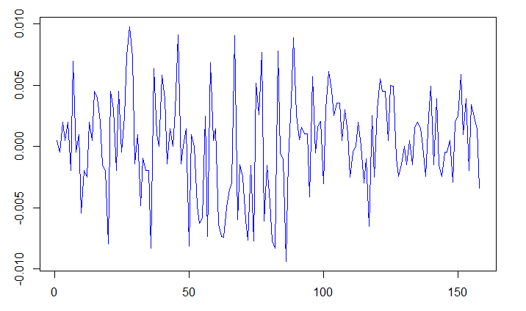
Figure 1. Graphs of Data

Table headings should be centered above the tables.

Table 1. Statistics Descriptive
Variables | Minimum | Maximum |  | Mean
$$X_{1}$$ | 99.50 |  | 108.00 |  | 103.82
$$X_{2}$$ | 95.35 |  | 104.75 |  | 100.52
$$X_{3}$$ | 97.65 |  | 117.50 |  | 108.75
$$X_{4}$$ | 88.45 |  | 106.85 |  | 98.44

- MATERIAL AND METHOD
  - Subsection of Material and Method
This section contains data sources, research variables, sampling techniques, data collection methods and data analysis methods. The data analysis method used must be described in detail.
  - Subsection of Material and Method
This section contains data sources, research variables, sampling techniques, data collection methods and data analysis methods. The data analysis method used must be described in detail.

- RESULTS AND DISCUSSION
Results should be clear and concise. The results should summarize (scientific) findings rather than providing data in detail. Please highlight differences between your results or findings and the previous publications by other researchers. The discussion should explore the significance of the results of the work, not repeat them. A combined Results and Discussion section is often appropriate. Avoid extensive citations and discussion of published literature.
In discussion, it is the most important section of your article. Here you get the chance to sell your data. Make the discussion corresponding to the results, but do not reiterate the results. Often should begin with a brief summary of the main scientific findings (not experimental results).

- CONCLUSION
Conclusions should only answer the objectives of the research. A conclusion might elaborate on the importance of the work or suggest applications and extensions.

ACKNOWLEDGMENT
The authors can add in the acknowledgement if they would like to express their appreciation for the support of the sponsors with certain Project No, individual or organization/institution.

REFERENCES
References list must follow American Psychological Association (APA). Please use Reference Manager Applications like Mendeley, EndNote, Zotero, etc. The minimum number of references should be 15 references.

Authors Last Name, Initial(s). (year). Book Title. Edition. Place: Publisher. ← Book
Jorion, P. (2007). Value at Risk: The New Benchmark for Managing Financial. New York: McGraw-Hill Companies.
Authors Last Name, Initial(s). (year). Article Title. Journal Title. Volume (Issue Number: optional), page number start-page number end. DOI information. ← Journal
Viceira, L. M. (2012). Bond risk, bond return volatility, and the term structure of interest rates. International Journal of Forecasting, 28(1), 97–117. DOI: 10.1016/j.ijforecast.2011.02.018.
Authors Last Name, Initial(s). (year). Article Title. Proceedings Title. Volume (Issue Number: optional), page number start-page number end. DOI information. ← Proceeding
Maruddani, D.A.I & Trimono, T. (2018) Modeling Stock Prices in a Portfolio Using Multidimensional Geometric Brownian Motion. Journal of Physics: Conference Series, Vol. 1025. DOI: 10.1088/1742-6596/1025/1/012122.

